ECG Recording

The following ECG signals were recorded. Recordings were taken over 20seconds. No programmable gain has been used. Note that channel 3is currently unavailable due to a fault in the circuit.

I made use of these two recordings simply because one has more noise than the other, which probably has something to do with the system/cables/etc moving around. Apart from that the experimental conditions are exactly the same for both.

Recording A 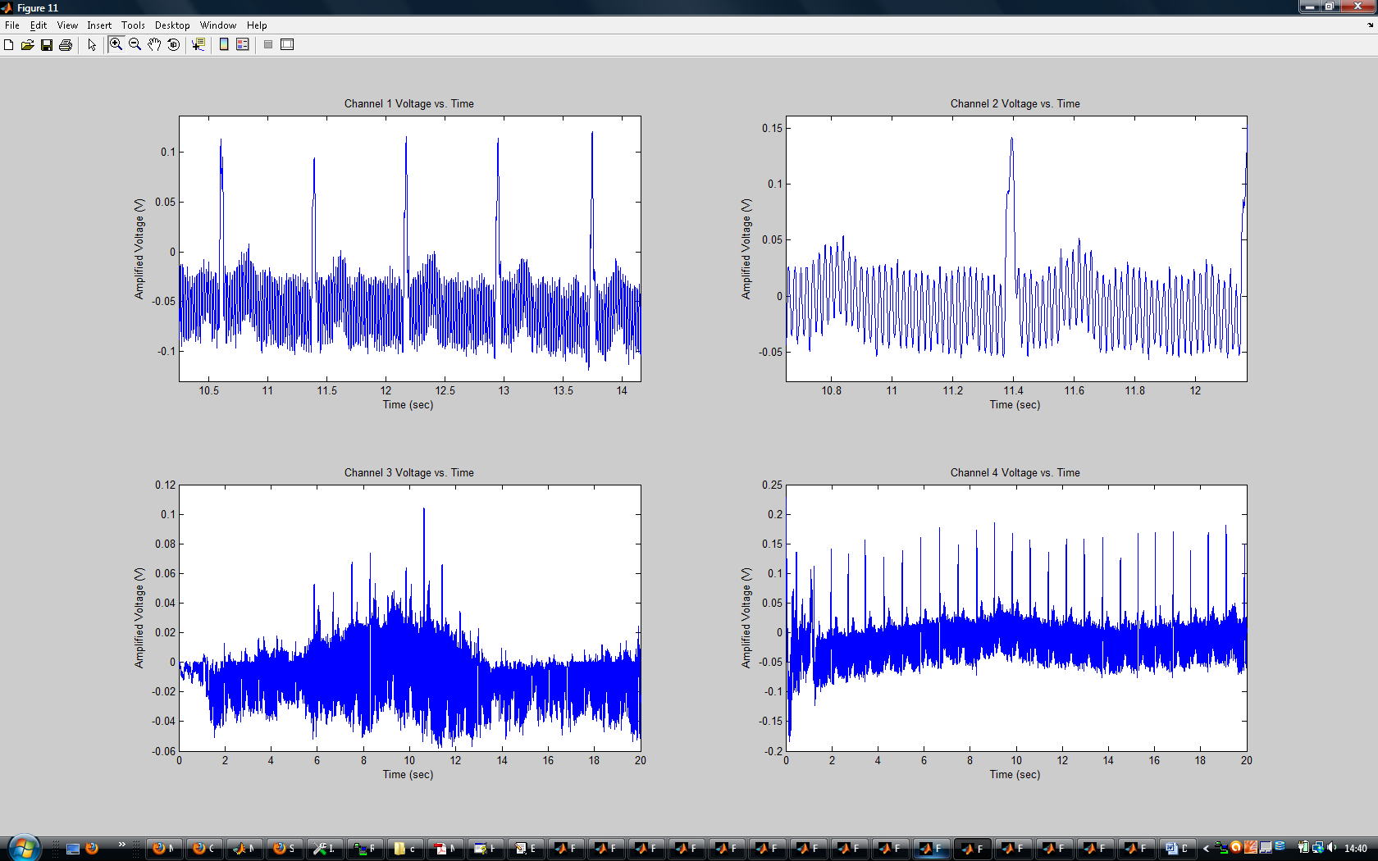

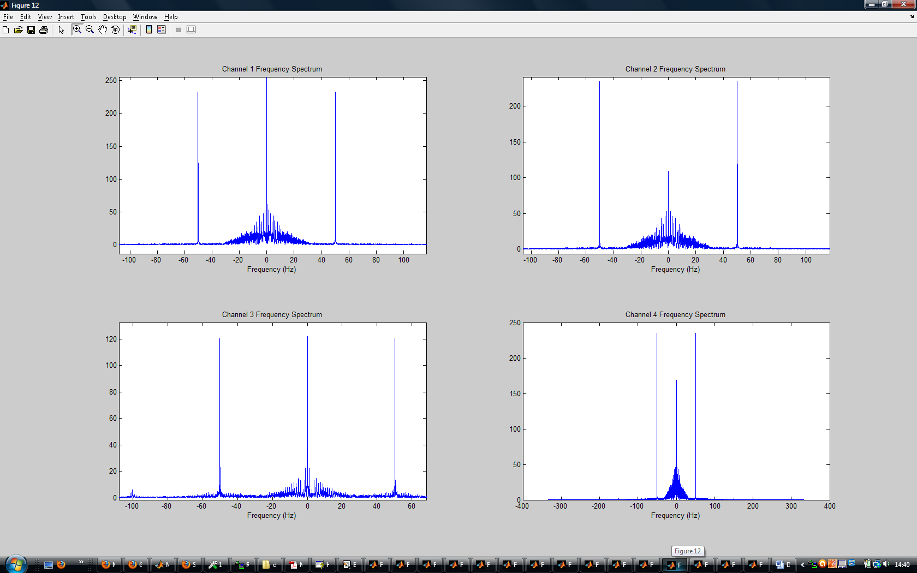

Recording B
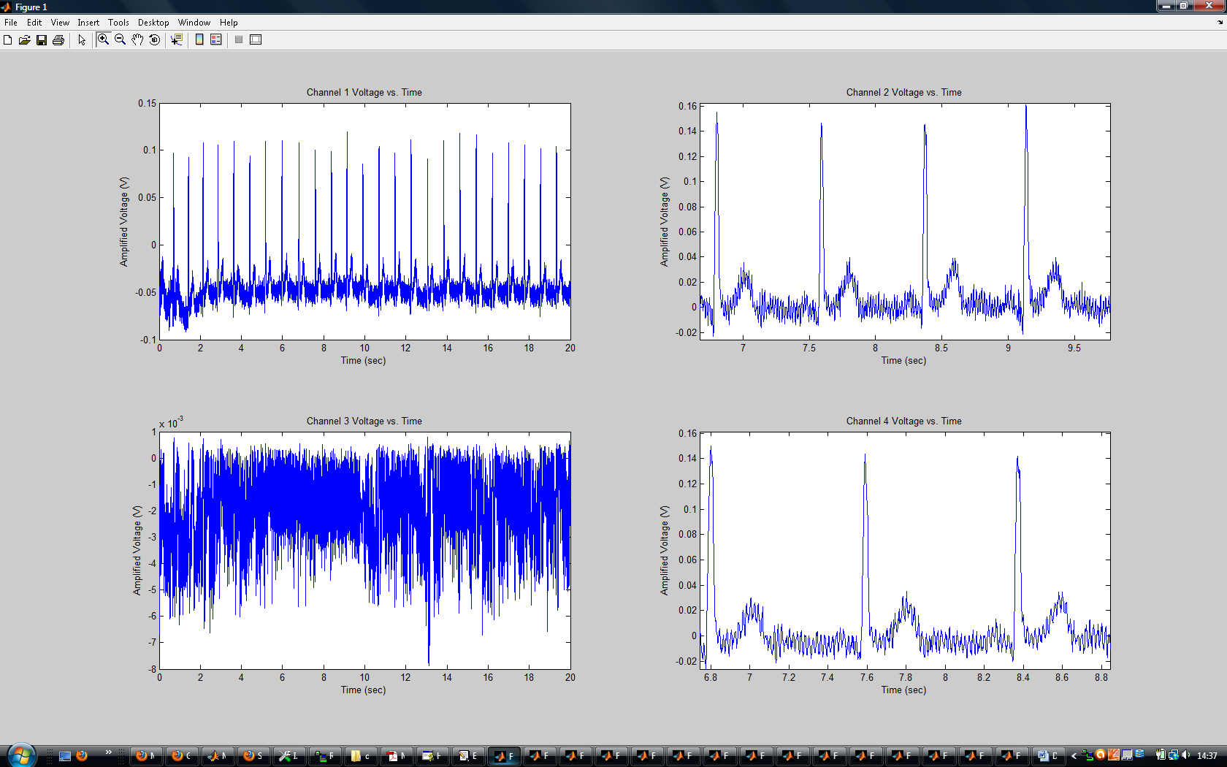

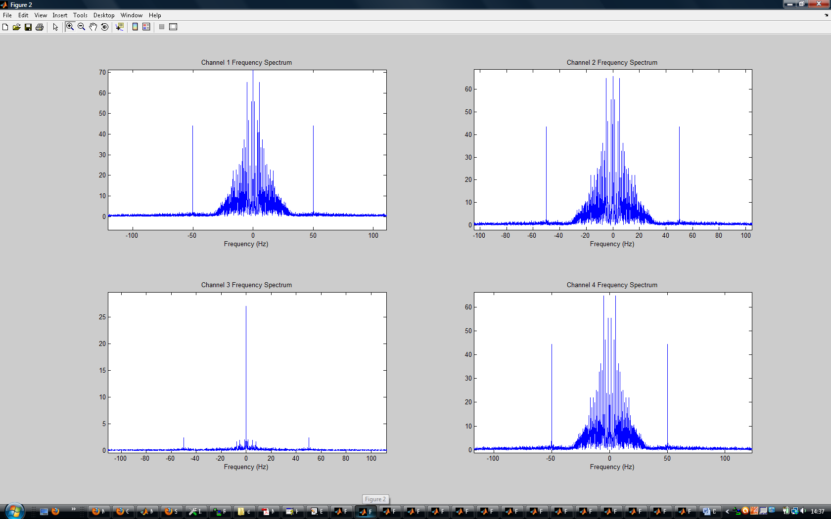

Use of 50Hz Notch Filter
For the hell of it I decided to throw in a notch filter to see how the ECG looks without the 50Hz noise. I don’t plan on substituting good shielding for digital filtering - it’s just to see what the EEG looks like without the 50Hz noise. Recordings A and B are now subjected to this filter:

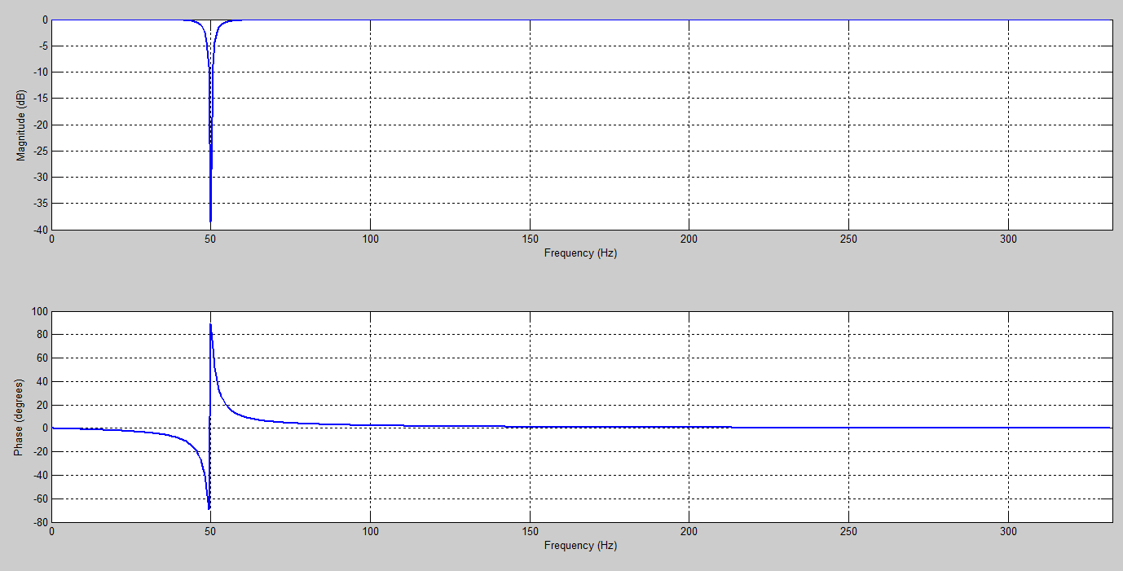

Recording A (filtered)
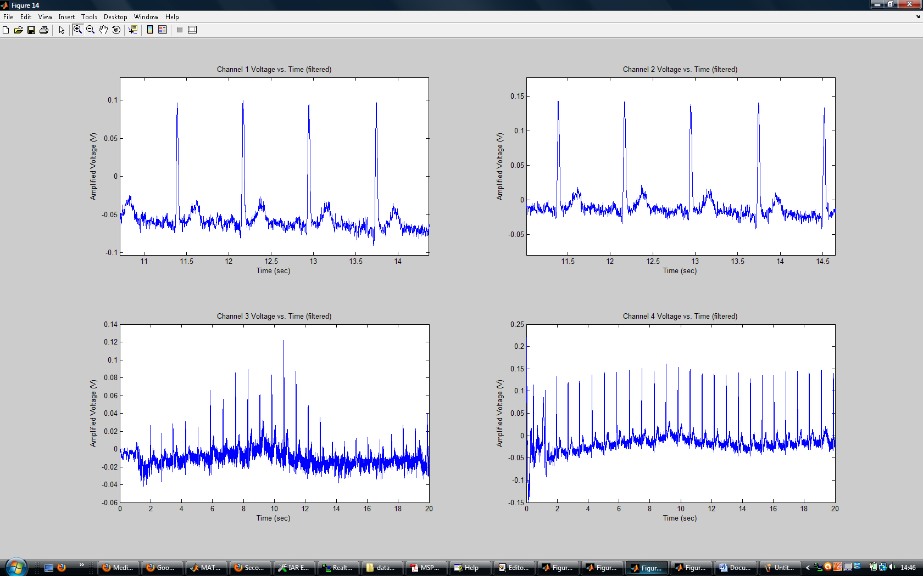

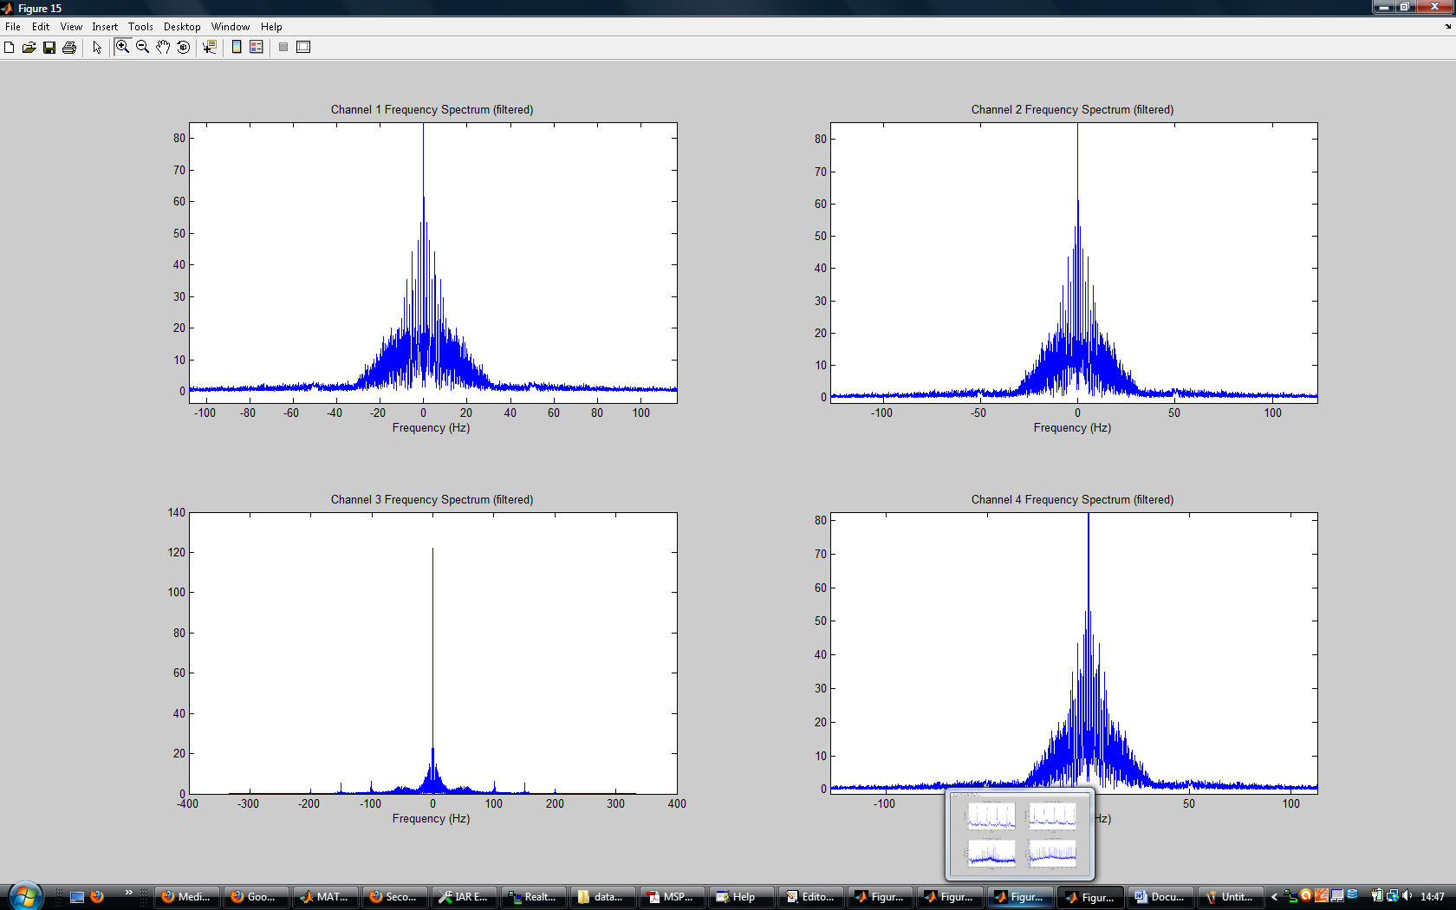

Recording B (filtered)

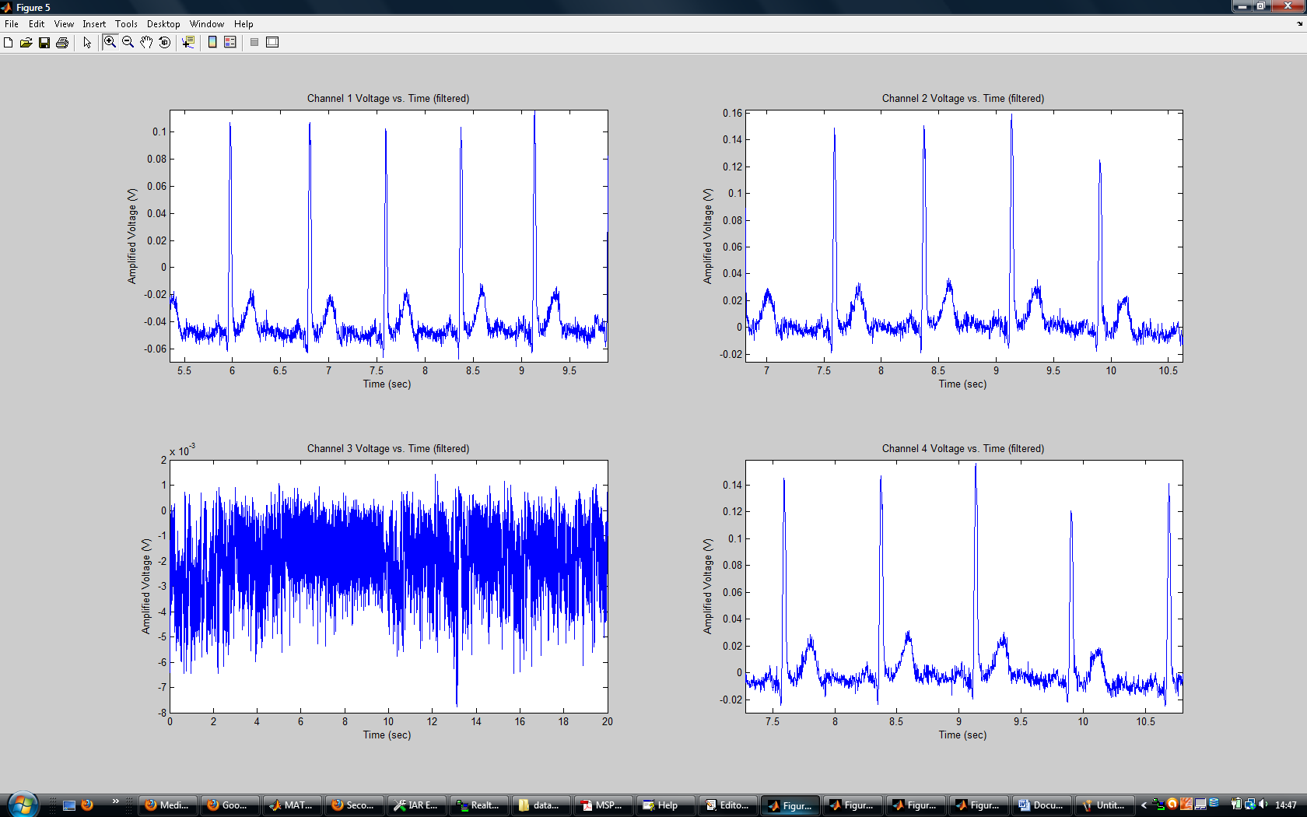

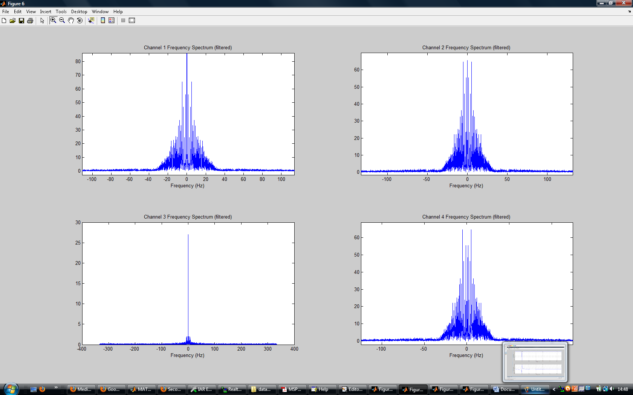

A final note: PGA doesn’t seem to reduce the 50Hz noise, as that’s part of the signal as far as the ADC is concerned, but I’m guessing would probably do something for the broad-spectrum noise that’s more of a problem when amplifying ultra-small signals. Either way, I wouldn’t notice that distinction at signals of this magnitude.

Serial Data Transmission

Packet Format
Each and every sample taken with the A2D converter results in 24 bits of data that is eventually transmitted along the serial port. 16-bits are the data, 8-bits are added overhead that comprises of:
- 1st frame identifier bit
- Channel identifier bits
- Status bits

Thus 4 samples taken (1 for each channel) results in a total of 12 bytes, which makes up a single burst transmission, of which in between samples are collected.

The 24-bit word for each sample has the following format:

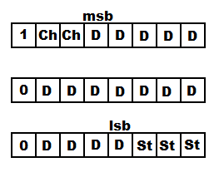
Where:
1 = at the beginning of the first byte marks the beginning of the 24-bit word
0 = at the beginning of the second and third bytes show that they’re not the first byte in the 24-bit word
Ch = channel identification bits, which identifies the word as channel 1, 2, 3 or 4
D = 16-bit data stream, with most significant bit (msb) and least significant bit (lsb) marked
St = Status bits - which can hold 9 status values as to the condition of the transmitter. One I know I’ll include is ‘dbs on’, where bits are set to indicate that DBS is currently running. Currently set as zeros as default.

The format of the 16-bit word is bipolar-offset binary, and so no sign bits are used. In this case +/-0.6V value ranges from 0 to 65535, with -0.6V taking the value 0 (0x0000), 0V taking the value 32768 (0x8000), and +0.6V taking the value 65536 (0xFFFF).

For optimal timing, to preserve synchronisation and to keep each and every sample periodic, burst transmissions are made between the transmitter and receiver once a sample is collected from each of the 4 channels (i.e. I don’t collect a heap of samples before transmission). If a burst transmission is bad, the entire 4 samples are discarded at the transceiver (receiver end) rather than select bytes, meaning that the serial port will always read bytes starting with ‘1,0,0,1,0,0,1,0,0,...etc...’ in that order, unless of course the 32-bit CRC for each burst is passed irrespective of an erroneous 1 or 0 at the beginning of each byte (I so far haven’t encountered this and I’ve got code that checks / corrects this order in Matlab anyway, preserving synchrony). Thus each burst transmission will result in the following bits arriving at the serial port. This pattern is repeated over and over:

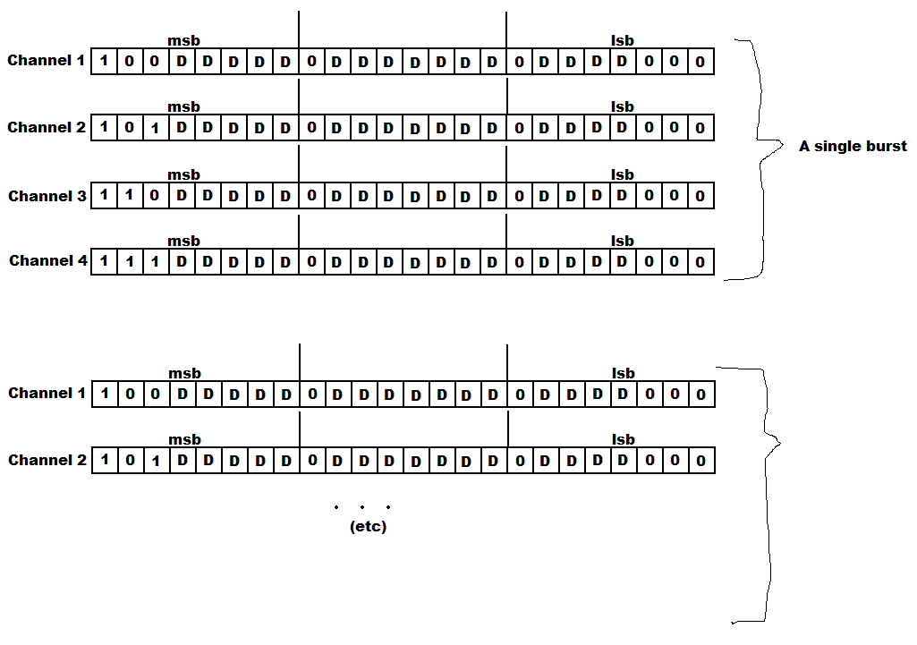
The actual bit rate that bits arrive at the serial port is 115.2Kbaud/sec, which is sufficient to keep up with the transmission from the EEG recorder.

Note that additional address/status/CRC bytes are added to each burst at the EEG recorder end that is removed at the transmitter side prior to being passed to the serial port. Most of these bytes are things like status bytes, CRC bytes, etc, that are added and removed automatically by the transceiver. Only the bytes shown above will reach the serial port.

UART Protocol
Bytes are passed through the serial port using an 8-N-1 UART protocol, where for every 8 bits there is an additional start and stop bit appended to the beginning and end of each byte, making up a 10-bit word. In this case the start bit is ‘1’ and the stop bit is ‘0’. I think the serial port removes this as these bits signal ‘byte start’ and ‘byte finish’ for asynchronous communication. Needless to say I get successive 8-bit values from the software I’m using Realterm, rather than 10-bit values containing the start and stop bits.

Packet Handling Code
The software I’m using saves the entire data stream as a text file consisting of hexadecimal values. The Matlab program I’ve written opens this text file, converts this stream to integer values, sets the start point as channel 1, sorts the frames into their correct channel arrays (checking and discarding frames that don’t fit the correct sequence), discards channel and status bits, converts each sample to their corresponding 16-bit numbers, gets the time/frequency/voltage scales right, and displays the results in the time and frequency domain. I’ve included the Matlab code showing how I went about this:

%**************************************************************************
% chout2.m
%**************************************************************************
%
% Richard Pinnell November 2009
%**************************************************************************

format long

% opens the file to read
A=fopen('capture.txt','r');

%stores all characters in the file to character string tline
tline=fgetl(A);

%first thing to do is to convert all these characters to hex values in an
%array so I can work with them.

%finds out the length of the output character array
size = length(tline);

B=zeros(1,size);

% converts all ascii characters to their corresponding hex values, array
% format is in integer. So A = 10, F = 15, 1 = 1, etc.
for i=1:size,
if (isletter(tline(i))==1)
B(1,i)=tline(i)-55;
else
B(1,i)=tline(i)-48;
end
end

% this bit looks for the first byte from channel 1 to act as start point,
% and chops away the bytes before it.
cut = 0;
for j=1:24,
if ((B((2*j)-1)== 8) || (B((2*j)-1)==9))
cut = (2*j)-1;
end
end
cut = cut - 1;
size = size-cut;
size = size - rem(size,24);

% modifies the array to start on the first packet of channel 1
C = zeros(1,size);
for k=1:size,
C(k)=B(k+cut);
end

% makes 4 new arrays for storing each channel of information in

Ch1count = 1;
Ch2count = 1;
Ch3count = 1;
Ch4count = 1;

% Next bit sorts through the array, placing every 3 frames tagged with
% channel bits into the appropriate channel matrices. Errenous frames
% that don't follow the '1,0,0,1,0,0 format are discarded, and the program
% moves onto the next one.

% In this case the channel matrices contain the 24-bits of channel
% information split over 6 columns (4-bits or one hex value per column),
% where each row represents a new sample with 24-bits of information.
% The 8-status bits are removed later.

size2 = size/12;

Ch1 = zeros(size2,6);
Ch2 = zeros(size2,6);
Ch3 = zeros(size2,6);
Ch4 = zeros(size2,6);

for j=1:((size/2)-6),
if ((C((2*j)-1)== 8) || (C((2*j)-1)==9))
if ((C((2*j)+1)<8) && (C((2*j)+3)<8))
Ch1(Ch1count,1) = C((2*j)-1);
Ch1(Ch1count,2) = C(2*j);
Ch1(Ch1count,3) = C((2*j)+1);
Ch1(Ch1count,4) = C((2*j)+2);
Ch1(Ch1count,5) = C((2*j)+3);
Ch1(Ch1count,6) = C((2*j)+4);
Ch1count = Ch1count+1;

end
elseif ((C((2*j)-1)== 10) || (C((2*j)-1)==11))
if ((C((2*j)+1)<8) && (C((2*j)+3)<8))
Ch2(Ch2count,1) = C((2*j)-1);
Ch2(Ch2count,2) = C(2*j);
Ch2(Ch2count,3) = C((2*j)+1);
Ch2(Ch2count,4) = C((2*j)+2);
Ch2(Ch2count,5) = C((2*j)+3);
Ch2(Ch2count,6) = C((2*j)+4);
Ch2count = Ch2count+1;
end
elseif ((C((2*j)-1)== 12) || (C((2*j)-1)==13))
if ((C((2*j)+1)<8) && (C((2*j)+3)<8))
Ch3(Ch3count,1) = C((2*j)-1);
Ch3(Ch3count,2) = C(2*j);
Ch3(Ch3count,3) = C((2*j)+1);
Ch3(Ch3count,4) = C((2*j)+2);
Ch3(Ch3count,5) = C((2*j)+3);
Ch3(Ch3count,6) = C((2*j)+4);
Ch3count = Ch3count+1;
end
elseif ((C((2*j)-1)== 14) || (C((2*j)-1)==15))
if ((C((2*j)+1)<8) && (C((2*j)+3)<8))
Ch4(Ch4count,1) = C((2*j)-1);
Ch4(Ch4count,2) = C(2*j);
Ch4(Ch4count,3) = C((2*j)+1);
Ch4(Ch4count,4) = C((2*j)+2);
Ch4(Ch4count,5) = C((2*j)+3);
Ch4(Ch4count,6) = C((2*j)+4);
Ch4count = Ch4count+1;
end
end
end

% the following 4 arrays are made to contain the conditioned samples, i.e.
% simply 16-bit integers per row without any of the overhead.

Channel1 = zeros((Ch1count-1),1);
Channel2 = zeros((Ch2count-1),1);
Channel3 = zeros((Ch3count-1),1);
Channel4 = zeros((Ch4count-1),1);

% the following code takes out the channel bits, then sorts and adds up the
% remaining 16-bits into a whole number, and sticks it into the arrays
% created just above

for i=1:(Ch1count-1),
Ch1(i,1)=Ch1(i,1)-8;
Channel1(i,1)= (Ch1(i,6)/8)+(Ch1(i,5)*2)+(Ch1(i,4)*16)+(Ch1(i,3)*256)+(Ch1(i,2)*2048)+(Ch1(i,1)*32768);
end
for i=1:(Ch2count-1),
Ch2(i,1)=Ch2(i,1)-10;
Channel2(i,1)= (Ch2(i,6)/8)+(Ch2(i,5)*2)+(Ch2(i,4)*16)+(Ch2(i,3)*256)+(Ch2(i,2)*2048)+(Ch2(i,1)*32768);
end
for i=1:(Ch3count-1),
Ch3(i,1)=Ch3(i,1)-12;
Channel3(i,1)= (Ch3(i,6)/8)+(Ch3(i,5)*2)+(Ch3(i,4)*16)+(Ch3(i,3)*256)+(Ch3(i,2)*2048)+(Ch3(i,1)*32768);
end
for i=1:(Ch4count-1),
Ch4(i,1)=Ch4(i,1)-14;
Channel4(i,1)= (Ch4(i,6)/8)+(Ch4(i,5)*2)+(Ch4(i,4)*16)+(Ch4(i,3)*256)+(Ch4(i,2)*2048)+(Ch4(i,1)*32768);
end

% At present the arrays above contain a number per row ranging from 0 to 65535,
% representing 0-1.2V. These values are then simply converted to lie
% between - and + 0.6

Channel1 = Channel1/54612.5;
Channel1 = Channel1-0.6;
Channel2 = Channel2/54612.5;
Channel2 = Channel2-0.6;
Channel3 = Channel3/54612.5;
Channel3 = Channel3-0.6;
Channel4 = Channel4/54612.5;
Channel4 = Channel4-0.6;

% As 20 seconds of recordings are made, the following code sets the time
% and frequency scales for each channel. In case for some reason one
% channel has more samples than another (through bytes being discarded
% above), they each have their seperate scale calculated to compensate.
% Note that Realterm terminal software doesn't exactly record 20 seconds,
% but averaging the results over 20-seconds is much more accurate than
% attempting say, 2-second recordings.

time1=(1:(Ch1count-1));
freq1 = time1/20;
time1=(20/(Ch1count-1))*time1;
freq1 =freq1 - (max(freq1)/2);

time2=(1:(Ch2count-1));
freq2 = time2/20;
time2=(20/(Ch2count-1))*time2;
freq2 =freq2 - (max(freq2)/2);

time3=(1:(Ch3count-1));
freq3 = time3/20;
time3=(20/(Ch3count-1))*time3;
freq3 =freq3 - (max(freq3)/2);

time4=(1:(Ch4count-1));
freq4 = time4/20;
time4=(20/(Ch4count-1))*time4;
freq4 =freq4 - (max(freq4)/2);

% Now to plot the signals...

figure;subplot(2,2,1);
plot(time1,Channel1)
ylabel('Amplified Voltage (V)');
xlabel('Time (sec)');
title('Channel 1 Voltage vs. Time');

subplot(2,2,2)
plot(time2,Channel2)
ylabel('Amplified Voltage (V)');
xlabel('Time (sec)');
title('Channel 2 Voltage vs. Time');

subplot(2,2,3)
plot(time3,Channel3)
ylabel('Amplified Voltage (V)');
xlabel('Time (sec)');
title('Channel 3 Voltage vs. Time');

subplot(2,2,4)
plot(time4,Channel4)
ylabel('Amplified Voltage (V)');
xlabel('Time (sec)');
title('Channel 4 Voltage vs. Time');

figure;subplot(2,2,1);
plot(freq1,abs(fftshift(fft(Channel1))));
xlabel('Frequency (Hz)');
title('Channel 1 Frequency Spectrum');

subplot(2,2,2)
plot(freq2,abs(fftshift(fft(Channel2))));
xlabel('Frequency (Hz)');
title('Channel 2 Frequency Spectrum');

subplot(2,2,3)
plot(freq3,abs(fftshift(fft(Channel3))));
xlabel('Frequency (Hz)');
title('Channel 3 Frequency Spectrum');

subplot(2,2,4)
plot(freq4,abs(fftshift(fft(Channel4))));
xlabel('Frequency (Hz)');
title('Channel 4 Frequency Spectrum');

